**Practical 7: Deploy a Web Application on AWS**

**Solution:**

Step 1. Go to AWS dashboard, search and select **Elastic BeanStalk**

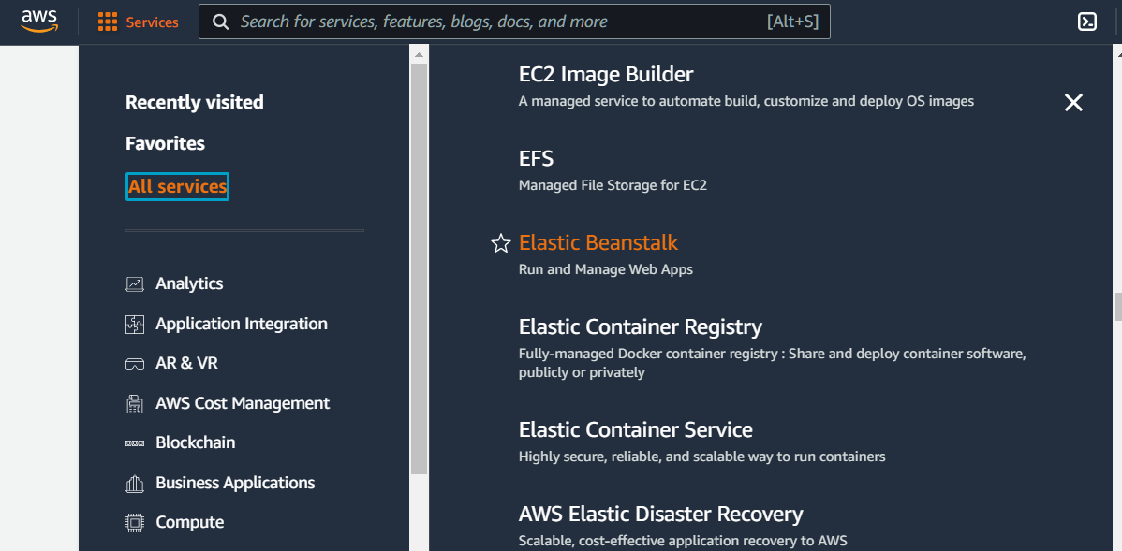

Note: If the status in the Health column is not Green, it has not finished starting yet. Wait a

few moments, and it should change to Green.

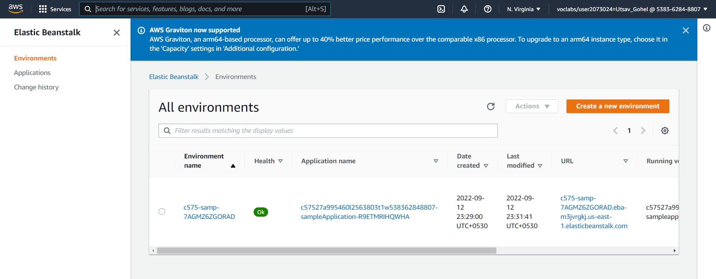

Step 2: Under the **Environment name** column, choose the name of the environment.

The **Dashboard** page for your Elastic Beanstalk environment opens.

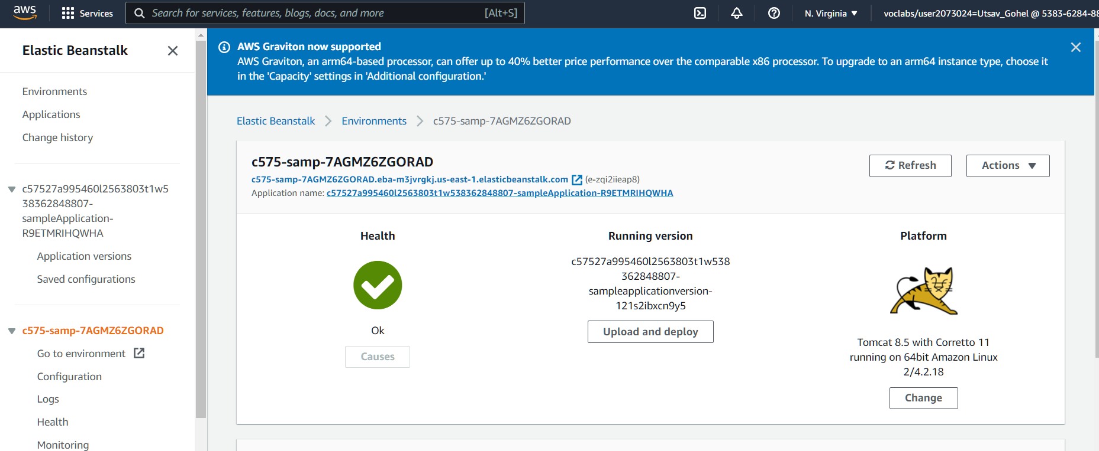

Step 3: Download sample file from given link and upload to running version center one as shown in figure

<https://docs.aws.amazon.com/elasticbeanstalk/latest/dg/samples/tomcat.zip>

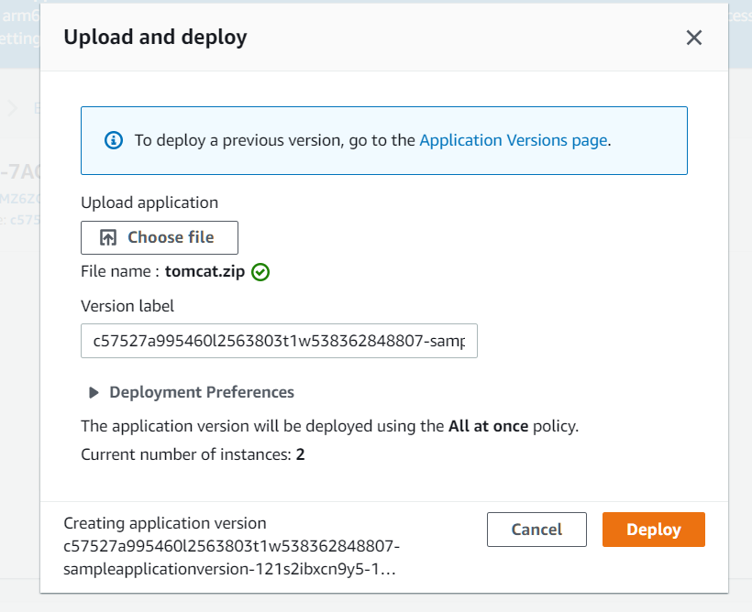

Step 4: Just copy the link of website and search in browser

<http://c575-samp-7agmz6zgorad.eba-m3jvrgkj.us-east-1.elasticbeanstalk.com/>

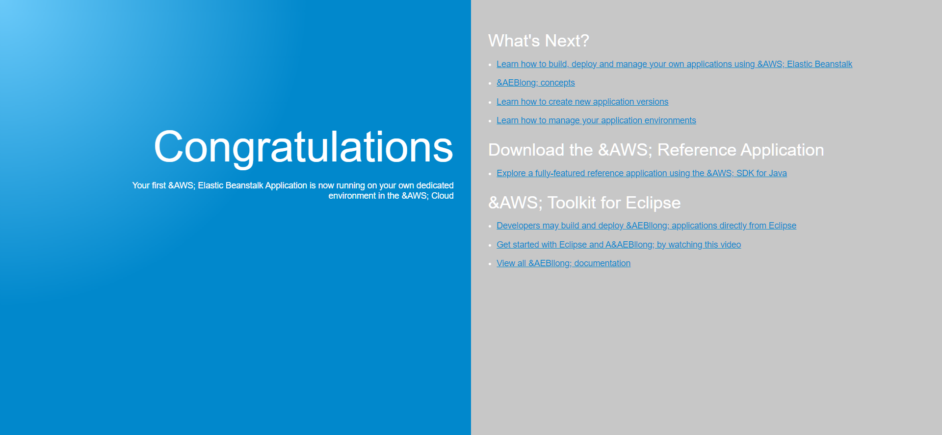

Thus your Website is Deployed on AWS